Please note you must download the SIMS Parent App first before opening the email and activating the link.

1: Download SIMS Parent App
- From the Apple App Store or Google Play Store – search for SIMS Parent and download app to your phone or tablet

2: Registration Email

- Check your email for a message from noreply@sims.co.uk – click on the email
- Enter the activation code
- You will receive an activation code for each child you have enrolled in the school
- You must click on the link and complete the registration process to verify your account before signing into the app

3: Sign in to SIMS Parent
- To sign in to SIMS Parent you will need one of the following accounts: Microsoft,
Office 365, Google, Facebook or Twitter.
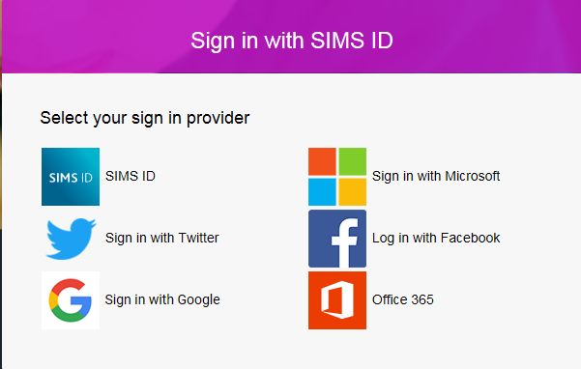

4: Troubleshooting

What If? | What to do
If you have any difficulty downloading the app or require activation codes to be resent | Contact the school:  info@brownlowcollege.craigavon.ni.sch.uk
I don’t have any of the accounts required  Microsoft, Twitter, Google, Facebook,  Office365 | You will need to setup an account with one of the providers

