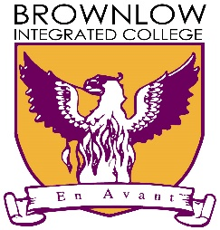

Brownlow Integrated College

KEY WORKER COVID-19 APPLICATION

Please complete the following information accurately and in full.

Key Worker & Pupil Information

Name of Child:

Form Class:

Key worker 1

Name: Mobile Number:

Occupation: Hours of Work:

Employer: Employer Address:

Employer telephone number:

Key worker 2

Name: Mobile Number:

Occupation: Hours of Work:

Employer: Employer Address:

Employer telephone number:

Qualifying Questions

Please delete as appropriate:
- Are you a single parent and a key worker? YES / NO
- Are both parents key workers? YES / NO
- Have all other childcare options been exhausted? YES / NO

Declaration & Disclaimer

I certify that my answers are true and complete to the best of my knowledge. I understand that false or misleading information will result in a place being withdrawn.
The school will assess the merits of each application form and attempt to facilitate as many children of ‘key workers’ as they can within the confines of current resources, staffing levels and remote learning commitments, ratios and adequate health and safety standards as per PHA advice.
Parents will be notified as soon as possible if a place has been allocated to them. Please note we do not know how long we will be able to provide this service. We will be unable to provide this service during normal school holidays.
Qualifying parents that have not been accepted for a place will have their child(ren) placed on a waiting list and will be notified, if a place becomes available.
Parents should be aware that whilst we will do our best to ensure that adequate measures are taken to prevent the spread of COVID-19, we cannot guarantee that this virus we not be passed at our school.
Parents should also note that a place may be withdrawn without any notice if PHA advice changes or the operational capacity of the school means that it is no longer able to resource this scheme. This may be on a temporary basis or permanently, depending on the circumstances.
Please be aware that if your child hurts him or herself or becomes unwell, there must be someone available to pick him/ her up immediately.

Children must not be sent into school if they have been in contact with a confirmed case of COVID-19 or if they have a fever or cough. Children presenting with these symptoms will be sent home immediately.

Signature: Date:

