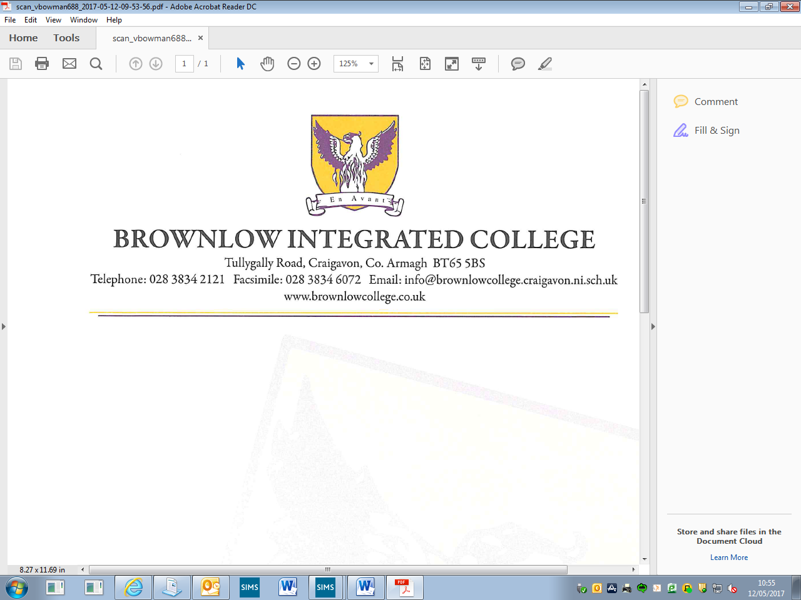December 2020

Dear Parent/Guardian

**Re: Year 9 Pupils**

The December Examinations are being held during the week Thursday 10 December 2020 until Wednesday 16 December 2020 and the following arrangements have been made.

Pupils should attend school at the normal start time each day.

Pupils will finish each day at 12.20pm to facilitate study time for pupils in the afternoons.

The canteen will be serving lunch at 12.20pm until 12.45pm each day.

Pupils should be collected from school at either 12.20pm or if having a lunch 12.45pm each day during the examinations. There will be no school buses provided in the afternoons of the exam week.

A copy of the examination timetable has been included with this letter to help your child with preparation for these December Examinations.

A report of your child’s progress will be forwarded to you in mid-January 2021.

Thank you for your continued support and partnership with your child’s education.



Yours sincerely

V Bowman

Curriculum Leader