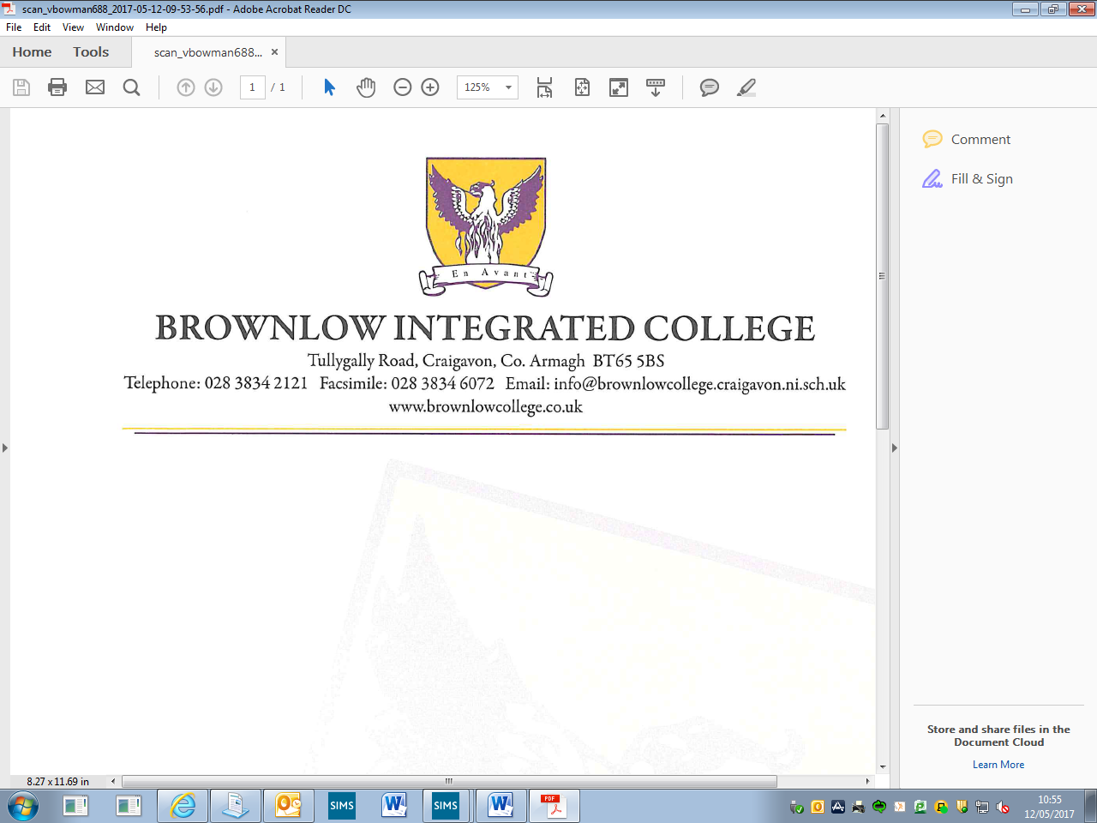December 2020

Dear Parent/Guardian

**Re: Year 12 Pupils**

The December Examinations are being held during the week Thursday 10 December 2020 until Wednesday 16 December 2020 and the following arrangements have been made.

Pupils should attend school at the normal start time each day unless timetabled for Exam Leave.

Pupils will finish each day at 12.55pm to facilitate study time for pupils in the afternoons.

The canteen will be serving lunch at 12.55pm until 13.30pm each day.

Pupils should be collected from school at either 12.55pm or if having a lunch 13.30pm each day during the examinations unless timetabled for study leave at a different time according to timetable. There will be no school buses provided in the afternoons of the exam week.

A copy of the examination timetable has been included with this letter to help your child with preparation for these December Examinations.

A report of your child’s progress will be forwarded to you in mid-January 2021.

Thank you for your continued support and partnership with your child’s education.



Yours sincerely

V Bowman

Curriculum Leader