BROWNLOW INTEGRATED COLLEGE

EQUALITY AND DIVERSITY POLICY

2020 – 2021

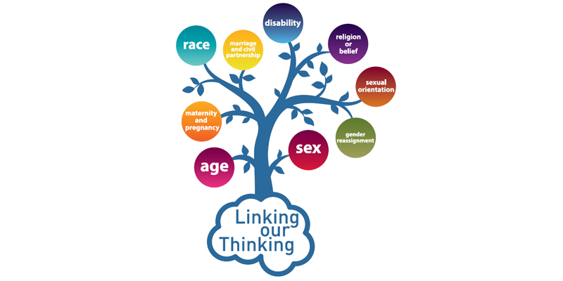

Policy Statement

We all live in a diverse society in 21st century Northern Ireland. Brownlow Integrated College is committed to creating an environment for the whole school community that demonstrates shared values of inclusion, equality, fairness and respect.

Our school recognises and celebrates difference within a culture of respect and fairness, and aims to meet the needs of every child in line with the principles of the Equality Act 2010.

The Equality Act 2010 harmonised nine separate pieces of legislation into one single Act simplifying the law and strengthening it in important ways to help tackle discrimination and inequality in the workplace and all other areas of life.
The Equality Act was introduced to offer legal protection to those people with one or more ‘protected characteristics’. The protected characteristics are:
- Age.
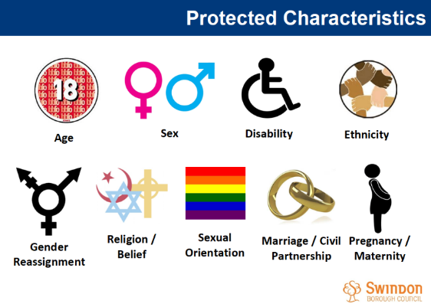
- Disability.
- Gender reassignment.
- Marriage and civil partnership.
- Pregnancy and maternity.
- Race.
- Religion or belief.
- Sex.
- Sexual orientation.
Equality and Diversity

Equality is about creating a fairer society, where everyone can take part and where everyone has the opportunity to be all they can be. Equality of opportunity has a legal framework to ensure protected groups are not discriminated against.
Diversity is about recognising and valuing difference, where everyone is respected for who they are.

Aims

In Brownlow Integrated College we will all work together with our pupils, families and staff to ensure that inclusion and equality are part of all our activities. Our policy aims to:

- Promote positive attitudes and behaviours towards equality and diversity

- Promote understanding of equality and diversity through the school curriculum and ethos

- Help the school to meet these aims and fulfil our legal obligations

Our approach to equality and diversity is based on the following key principles:

- All learners are of equal value

Irrespective of their race; gender and gender identity; religious or belief; or sexual orientation. However, this does not mean we treat everyone the same, sometimes it means giving people extra help so that they have the same opportunities and outcomes as others.

- We recognise, respect and value difference and understand that diversity is a strength.

We take account of differences and strive to remove barriers and disadvantages which people may face, in relation to disability, ethnicity, gender, religion, belief or faith and sexual orientation. We believe that diversity is a strength, which should be respected and celebrated by all those who learn, teach and visit here.

- We foster positive attitudes and relationships.

We actively promote positive attitudes and mutual respect between groups and communities different from each other.

- We foster a shared sense of inclusion and belonging.

We want all members of our school community to feel a sense of belonging within the school and wider community and to feel that they are respected and able to participate fully in school life.

- We observe good equalities practice for our staff.

We ensure that policies and procedures benefit all employees and potential employees in all aspects of their work, including in recruitment and promotion, and in continuing professional development

- We have the highest expectations of all our children.

We expect that all pupils can make good progress and achieve/attain to their highest potential.

- We work to raise standards for all pupils, but especially for the most vulnerable.

We believe that improving the quality of education for the most vulnerable groups of pupils raises standards across the whole school.

- Challenging prejudice and stereotyping

We tackle negative prejudice and stereotyping. We challenge and report all incidents of prejudice based bullying, for example racist, homophobic or bullying of people because of a disability. We will also challenge gender-based and other stereotypes.

Responsibilities

Senior Leadership Team (SLT)

It is the responsibility of all SLT to:

- Ensure that staff act as role models of inclusive behaviour and practice
- Ensure that the School complies with its equality obligations
- Ensure that the School’s policies & procedures are monitored in light of this policy and the School’s wider equality obligations
- Ensure effective implementation of this policy and its and procedures
- Ensure that all staff are sufficiently aware and trained within equality & diversity
- Actively challenge and take appropriate action in any cases of discriminatory practice within the School, be it by staff, pupils, parents or visitors
- Have procedures in place to deal effectively with any reported incidents of discrimination, victimization or harassment
- Ensure that all visitors and contractors are aware of, and comply with this policy.

All Staff

It is the responsibility of all staff to:

- Positively role model inclusive behaviour
- Actively challenge any forms of discrimination, victimisation, harassment or bullying
- Promote an inclusive curriculum, identify and challenge bias and stereotyping within the curriculum and in the School’s culture
- Commit to broadening their knowledge, confidence and inclusive behaviour by attending relevant training and accessing information from appropriate sources.

The School will:

- Treat all members of the School community with respect and dignity and seek to provide a positive working and learning environment free from discrimination
- Endeavour to meet the needs of all children and ensure that there is no unlawful discrimination on the grounds of any of the protected characteristics listed above
- Ensure those pupils with a statement of special educational needs (or Education Health and Care Plan) receive necessary educational and welfare support
- Ensure that pupils with English as additional language receive additional support, such as extra English tuition, where required
- Monitor the admission and progress of pupils from different backgrounds
- Challenge inappropriate discriminatory behaviour by pupils, staff and parents
- Offer all pupils access to all areas of the curriculum, including being able to participate in a full range of extra-curricular activities
- Ensure that all staff are aware of their responsibilities promote equality of opportunity and are given appropriate training and support
- Work with parents and external agencies where appropriate to combat and prevent discrimination in School
- Ensure that it reviews, monitors and evaluates the effectiveness of inclusive practices.

Supporting Trans and Non-Binary Pupils

The term “trans” refers to the group of people whose gender is different from what was assigned to them at birth and those who are questioning their gender.

Trans young people are at a higher risk of mental illness, self-harm and suicide than the general population. Acceptance and accommodation can go a long way to help reduce these risks. Trans young people are particularly vulnerable to bullying and social isolation, with poor mental health outcomes as a result.

Terminology

Gender identity is a person’s internal sense of their own gender. Usually, this is male or female, and it usually matches with the gender assignment made at birth (listed on their birth certificate).

People who identify as the gender they were assigned at birth are cisgender.

People who identify as something different than the gender they were assigned at birth are transgender.

Being transgender is different than being lesbian, gay, bisexual or asexual. Gender is distinct from sexual orientation, and trans people can be of any sexual orientation, including heterosexual, lesbian, gay, bisexual and asexual.

Managing a Disclosure

A trans young person may ‘come out’ if they perceive school to be a safe space or one of the staff as someone they can trust.

If a disclosure is made to a member of staff, they must inform the designated teacher to ensure the young person is signposted to relevant information about organisations and resources to address any questions they may be having.

This is not a mental illness and so therefore is not a safeguarding or child protection concern.

Except where there is a child protection issue, a young person’s gender identity/trans status should not be disclosed to their parents or carers without their consent.

Disclosing a young person’s gender identity to a parent or carer

The school would encourage a young person to share this information with their parent(s)/carer(s) in order to access support. Where a young person asks the school to disclose their gender identity/trans status to their parents or carers, this will be handled sensitively. It may be the first time the parents/ carers have heard about this or even of trans issues generally.

Following the disclosure to parents/carers they will be advised to contact their GP regarding a referral to the Child and Adolescent Mental Health Service (CAMHS) in order to access the specialised Gender Identity Service/Knowing Own Identity (KOI).

Families will be signposted to information on family support organisations for help and guidance such as SAIL NI.

If the parents/carers are hostile or are having difficulties accepting the young person it may be deemed necessary to contact Social Services in line with the school’s Safeguarding Policy if there is a perceived risk to the young person.

A trans young person has the right not to disclose, including to their parents(s) carer(s) if they do not wish to disclose. This will be respected.

Where a trans pupil is known to the school, the school will:

- Listen to their needs and accommodate were possible
- Support a plan for initiating the use of the chosen name and pronouns consistent with the young person’s gender identity. In all cases this will be actioned following parental consent to do so, in the form of a written request to the Principal.
- Facilitate a gender neutral Uniform for all pupils
- Facilitate a gender neutral P.E. Uniform for all pupils
- Provide gender neutral toilet facilities
- Provide Accessible Changing Facilities
- Provide opportunities for gender neutral P.E. classes across a range of sports
- Reasonable adjustments can easily be implemented to accommodate the trans young person attending a residential or school trip, allowing them to avail of the same overnight educational opportunity as everyone else
- All staff will deal with questions relating to gender in a sensitive manner
- All incidents of transphobia will be dealt with immediately in line with the schools anti-bullying policy
- All pupils will be treated equally within Brownlow Integrated College by ALL members of staff

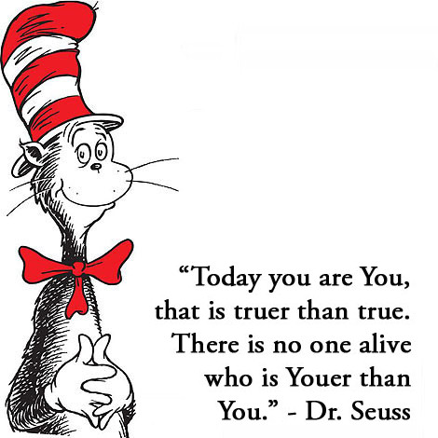
Related Policies

Anti-Bullying Policy
Safeguarding Policy
Integration Policy
Uniform Policy
Code of Conduct Policy
Admissions Policy
Newcomers Policy
SEN Policy

Appendix One

This policy aims to provide guidance and information on how we, as a school, effectively support transgender, non-binary and questioning young people.

This policy links with the United Nations Convention on the Rights of the Child (UNCRC) by taking into consideration the below articles of the UNCRC.

Article 12: children have the right to say what they think should happen, when adults are making decisions that affect them, and to have their opinions taken into account.

Article 14: children have the right to think and believe what they want, to practice their religion, as long as they are not stopping other people from enjoying their rights. Parents should guide their children on these matters.

Article 29: Education should develop each child’s personality and talents to the full. It should encourage children to respect their parents, and their own and other cultures.

Appendix Two

Equality Act 2010 Factsheet Attached

Appendix Three

Definitions of Protected Characteristics
Definitions all taken from the Legislation.gov.uk website
http://www.legislation.gov.uk/ukpga/2010/15/contents

Age

(1) In relation to the protected characteristic of age—
(a) a reference to a person who has a particular protected characteristic is a reference to a person of a particular age group;
(b) a reference to persons who share a protected characteristic is a reference to persons of the same age group.
(2) A reference to an age group is a reference to a group of persons defined by reference to age, whether by reference to a particular age or to a range of ages.

Disability

(1) A person (P) has a disability if—
(a) P has a physical or mental impairment, and
(b) the impairment has a substantial and long-term adverse effect on P's ability to carry out normal day-to-day activities.
(2) A reference to a disabled person is a reference to a person who has a disability.
(3) In relation to the protected characteristic of disability—
(a) a reference to a person who has a particular protected characteristic is a reference to a person who has a particular disability;
(b) a reference to persons who share a protected characteristic is a reference to persons who have the same disability.
(4) This Act (except Part 12 and section 190) applies in relation to a person who has had a disability as it applies in relation to a person who has the disability; accordingly (except in that Part and that section)—
(a) a reference (however expressed) to a person who has a disability includes a reference to a person who has had the disability, and
(b) a reference (however expressed) to a person who does not have a disability includes a reference to a person who has not had the disability.
(5) A Minister of the Crown may issue guidance about matters to be taken into account in deciding any question for the purposes of subsection (1).
(6) Schedule 1 (disability: supplementary provision) has effect.

Gender reassignment

(1) A person has the protected characteristic of gender reassignment if the person is proposing to undergo, is undergoing or has undergone a process (or part of a process) for the purpose of reassigning the person's sex by changing physiological or other attributes of sex.
(2) A reference to a transsexual person is a reference to a person who has the protected characteristic of gender reassignment.
(3) In relation to the protected characteristic of gender reassignment—
(a) a reference to a person who has a particular protected characteristic is a reference to a transsexual person;
(b) a reference to persons who share a protected characteristic is a reference to transsexual persons.

Marriage and civil partnership

(1) A person has the protected characteristic of marriage and civil partnership if the person is married or is a civil partner.
(2) In relation to the protected characteristic of marriage and civil partnership—
(a) a reference to a person who has a particular protected characteristic is a reference to a person who is married or is a civil partner;
(b) a reference to persons who share a protected characteristic is a reference to persons who are married or are civil partners

Race

(1) Race includes—
(a) colour;
(b) nationality;
(c) ethnic or national origins.
(2) In relation to the protected characteristic of race—
(a) a reference to a person who has a particular protected characteristic is a reference to a person of a particular racial group;
(b) a reference to persons who share a protected characteristic is a reference to persons of the same racial group.
(3) A racial group is a group of persons defined by reference to race; and a reference to a person's racial group is a reference to a racial group into which the person falls.
(4) The fact that a racial group comprises two or more distinct racial groups does not prevent it from constituting a particular racial group.
(5) A Minister of the Crown F1...—
(a) [F2must by order] amend this section so as to provide for caste to be an aspect of race;
(b) [F3may by order] amend this Act so as to provide for an exception to a provision of this Act to apply, or not to apply, to caste or to apply, or not to apply, to caste in specified circumstances.
(6) The power under section 207(4)(b), in its application to subsection (5), includes power to amend this Act.

Religion or belief

(1) Religion means any religion and a reference to religion includes a reference to a lack of religion.
(2) Belief means any religious or philosophical belief and a reference to belief includes a reference to a lack of belief.
(3) In relation to the protected characteristic of religion or belief—
(a) a reference to a person who has a particular protected characteristic is a reference to a person of a particular religion or belief;
(b) a reference to persons who share a protected characteristic is a reference to persons who are of the same religion or belief.

Sex

In relation to the protected characteristic of sex—
(a) a reference to a person who has a particular protected characteristic is a reference to a man or to a woman;
(b) a reference to persons who share a protected characteristic is a reference to persons of the same sex.

Sexual orientation

(1) Sexual orientation means a person's sexual orientation towards—
(a) persons of the same sex,
(b) persons of the opposite sex, or
(c) persons of either sex.
(2) In relation to the protected characteristic of sexual orientation—
(a) a reference to a person who has a particular protected characteristic is a reference to a person who is of a particular sexual orientation;
(b) a reference to persons who share a protected characteristic is a reference to persons who are of the same sexual orientation.

Direct discrimination

(1) A person (A) discriminates against another (B) if, because of a protected characteristic, A treats B less favorably than A treats or would treat others.
(2) If the protected characteristic is age, A does not discriminate against B if A can show A's treatment of B to be a proportionate means of achieving a legitimate aim.
(3) If the protected characteristic is disability, and B is not a disabled person, A does not discriminate against B only because A treats or would treat disabled persons more favorably than A treats B.
(4) If the protected characteristic is marriage and civil partnership, this section applies to a contravention of Part 5 (work) only if the treatment is because it is B who is married or a civil partner.
(5) If the protected characteristic is race, less favorable treatment includes segregating B from others.
(6) If the protected characteristic is sex—
(a) less favorable treatment of a woman includes less favorable treatment of her because she is breast-feeding;
(b) in a case where B is a man, no account is to be taken of special treatment afforded to a woman in connection with pregnancy or childbirth.
(7) Subsection (6)(a) does not apply for the purposes of Part 5 (work).
(8) This section is subject to sections 17(6) and 18(7).

Appendix Four

Relevant Terminology

Binding
Flattening of the chest to create the appearance of a “male” torso. This is commonly done by trans men and some non-binary people to hide breast tissue. It can be done safely and in moderation, but usually requires purpose-made clothing (binders).

Cisgender (often shortened to cis)
When one’s gender identity matches the gender assignment given at birth.

Gender
A person’s inner perceptions of being male, female, or otherwise. A transgender person’s gender is different than the gender assignment that was made at birth.

Gender Assignment
The designation of male or female that new-born children are typically given based on their sex characteristics. This typical assignment does not allow for intersex children or those who will grow up to be non-binary.

Gender Binary
The socially constructed idea that someone’s gender can be one of two options, either male or female. At time of publication, UK law only recognises someone’s gender as either male or female. Non-binary people and some intersex people fall outside the gender binary.

Gender confirmation (or reassignment/realignment)
Many trans people undergo medical procedures, including hormone replacement and surgery, to align their bodies to their gender. This has several names, but is most often called gender confirmation or gender reassignment. It is also sometimes referred to as sex assignment, though this term is falling out of use.

Gender dysphoria
The discomfort that many trans people have due to the incongruence between their gender and their bodies (sex characteristics). People with significant gender dysphoria often undergo gender confirmation to feel happier and more comfortable.

Gender expression
How a person displays or portrays their gender to others through dress and/or societal gender roles. See social presentation.

Gender fluid
Denoting or relating to a person whose gender identity or gender expression is not fixed and shifts over time or depending on the situation.

Gender neutrality
The idea that policies, language, and other social settings should avoid distinguishing. According to people’s sex or gender, in order to avoid discrimination. E.g. in sports, careers, changing rooms etc.

Gender recognition
The process through which many trans people go through to have their gender legally recognised by the government. At time of publication, gender recognition in Northern Ireland is only available to single trans people over the age of 18 who have a medical diagnosis of gender dysphoria. It is not available to non-binary people as UK law only recognises the gender binary.

Gender role
The social role assumed of people based on their gender. Stereotypical gender roles for boys/men and girls/women are often seen to be regressive and harmful when imposed on young people.

Intersex
Term for people whose physical sex is not definitively male or female. Intersex people are assigned a legal gender of either male or female at birth, and some people are surgically operated on without their consent as infants or young children. Some intersex people grow up to be transgender, and do not identify as the gender they were assigned at birth. Some intersex people identify as intersex and/or non-binary instead of male or female.

Non-binary
Term for people whose gender is outside the gender binary. This can include people who are neither male or female, somewhere in between, both or otherwise. It is an umbrella term covering many different identities.

Social presentation
The way a person “presents” is their gender expression. How a person presents affects how their gender is perceived by society. A person who presents in a feminine way is more likely to be perceived as female.

Sex (or sex characteristics)
A set of multiple characteristics of a person’s body that defines someone as male, female or otherwise. This includes genitalia, chromosomes, hormone levels and other physiological factors. Sex is a spectrum, with most people failing on either male or female. Some children are born intersex.

Trans boy/man
Term for a boy/man who was assigned female at birth.

Trans girl/women
Term for a girl/women who was assigned male at birth.

Transgender (often shortened to trans)
Term for people whose gender is different to the gender assignment that was made at birth. This includes trans men, trans women and non-binary people. It is an umbrella term to describe anyone who is not cisgender. Transgender should be used as an adjective (e.g. “a transgender person”)

Transphobia
Analogous to homophobia, this is the hatred or prejudice against trans people. This can take many forms, including violence, bullying, social rejection and discrimination by institutions.

Transsexual
Medical and legal term typically used to describe a trans man or women who transitions medically, legally and socially. It is used by some trans people to describe themselves, though is falling out of common use. It should not be used to describe a trans person unless at their request. Transsexual should be used as an adjective.

Transition
The process which many trans people go through to change some or all of the following: their social presentation, gender role, legal documents and/or bodies to better reflect their identities.

This can involve changing names, attaining gender recognition, adjusting their gender expression, and undergoing medical interventions.

Not all trans people transition, and transition is a personal process which means very different things to different people.

