BROWNLOW INTEGRATED COLLEGE

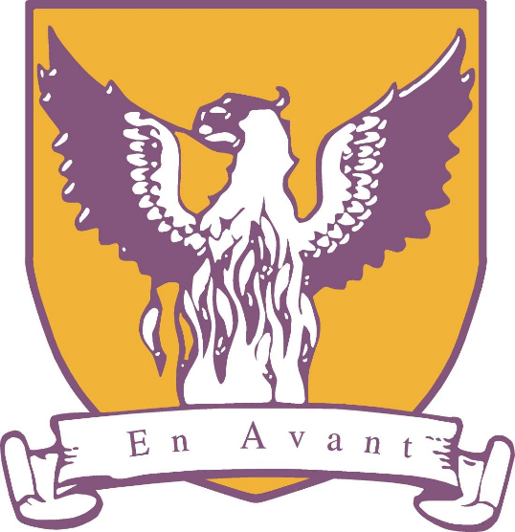

INTEGRATION POLICY

Brownlow Integrated College – Integration Policy

“Integrated Education brings children and staff from Catholic and Protestant traditions, as well as those of other faiths, or none, together in one school. For the past 30 years, in a deeply divided society, integrated schools have been an alternative to an educational system in which most children attend largely religiously separated schools.”
What is Integrated Education – NICIE (2016)

Brownlow Integrated College was the first school to transform to integrated status in 1991. Although the ethos of integration has remained the same since our transformation, the issues that we face as a society, and by consequence, as a school, we are constantly evolving. Therefore, this policy is intended as a guideline of the school’s approach to integration.

What we do

Integration is central to the ethos of our school. We offer a unique opportunity to interact, question and discuss issues in society that may not be provided in other schools. In BIC, we do this in a number of formal and informal ways.

Integration is formally taught through tailored lessons to all year eight students. The aim of these lessons is to celebrate diversity and learn about individual differences. The lessons are designed to be interactive exploring topics such as Bias, anti-bias, flags, symbols and emblems. It is an opportunity to ask questions about the history of Northern Ireland and how each of us fits into our school and society. We also celebrate events in our cultural calendar with assemblies and services, and participate in community celebrations and commemorations throughout the year, including Remembrance Sunday service and Ash Wednesday Mass.

Informally, children from diverse backgrounds who are educated together every day in the same classrooms are afforded a greater opportunity to experience integration through friendships and interaction with their peers.

We believe that the integrated approach to education can be used as a corporate approach to issues such as racism, sectarianism, sexism, homophobia, transgender and other prejudiced behaviours. Whilst the behaviours themselves will be dealt with in line with the school’s Positive Behaviour Policy and Anti-Bullying Policy, we would also seek to address the underlying causes of the behaviour.

Our minimum expectation of each pupil is understanding, tolerance and respect of others. Our goal is to foster the growth of every pupil, promoting their self-esteem, understanding and respect for each other.

How we do it

- All issues pertaining to integration are discussed by the integration committee (HAMS), which is made up of members of staff, Governors and pupils. The committee aims to develop confident integration structures throughout the school and to review the handling of issues which may be viewed as contentious or controversial. The committee offers advice to the Principal and Board of Governors to help inform their decision making on these and other issues of integration.

- All pupils, parents, staff and governors are issued with an Integration Pack which will inform all stakeholders of the history, ethos, policy and approaches of the school. This information is also prominently displayed throughout the school buildings.

- Representatives from HAMS regularly attend the NICIE Teachers’ Committee meetings. In addition, we work with NICIE to review best practice in Integrated Education, offering training and guidance to staff where appropriate.

- We welcome an active and supportive partnership with parents and the local community in order to ensure that our approaches to integration meet the needs of all stakeholders.

This policy is a working document and will be regularly reviewed to ensure its relevance and appropriateness in an ever changing society.

The College is embarking on a three-year journey to explore the core principles of Integrated Education which are Equality, Faith and Values; Parental involvement; Learning and Teaching. We want to set the challenge of measuring these core principles against our delivery in order to gain an Excellence in Integrated Education award

We believe that Integrated Education provides a unique opportunity for each and every student to bring their ideas, talents and energy to the school community as ‘creators, not just consumers.’ Integration at Brownlow offers students the opportunity to understand and discuss difference and diversity. When students leave Brownlow they are more confident and better prepared for their role in society.

