BROWNLOW INTEGRATED COLLEGE

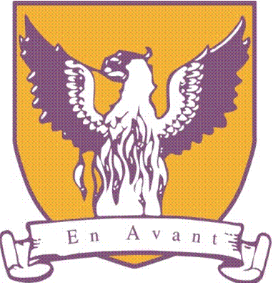

UNIFORM POLICY

Version | Author | Ratified by | Date
1 | Mrs Darrah | BOG | 16th May 2019

Introduction
UNIFORM is the outward identity of our school and the means by which you are distinguished in the wider community. Therefore, it is important that you have a pride in your school uniform and wear it smartly, neatly and correctly.
You must wear your full school uniform in and around school, for all school occasions and on journeys to and from school.
- Exceptions to the policy may be made on the grounds of religion, race or medical conditions.
- A blazer is a compulsory item of school uniform
- Trainers are only to be worn in PE or in exceptional circumstances.
- All items/articles of clothing must be clearly labelled with the pupil’s name.
- School shirts must be tucked in at all times.
- School ties must be worn when wearing a closed neck shirt.
- Full school uniform must be worn when representing the school.

The Principal’s decision on school uniform and your appearance is final.

PLEASE NOTE THAT ACCEPTANCE OF A PLACE IN BROWNLOW INTEGRATED COLLEGE REQUIRES ACCEPTANCE OF THE SCHOOL UNIFORM POLICY.

Enquiries about uniform should be made through the Head of Year or Senior Teachers.

*If a temporary deviation from regulation uniform has to be made, an explanation should be forwarded to the Form Teacher in writing or by telephone.

Brownlow Integrated College – School Uniform

Uniform Suppliers

Ivan Jameson  18 High Street  Portadown | Maxwells  87 Union Street  Lurgan | J&R Fashions  2 North Street  Lurgan | SD Kells  59 Market Street  Lurgan | The Gordon Group  Lurgan Town Arena  83 Glenavon Lane  Lurgan  BT66 8TN  (Hoodies only)

PE Kit and School Tracksuit are be purchased through the College PE Department

SCHOOL UNIFORM |  | PE KIT
Plain outdoor coat or fleece (optional) |  | Purple t-shirt with school crest or black t-shirt with school crest
Black blazer with school badge |  | Black Skort or black shorts
Black skirt, knee length, two pleats back and front or  Black trousers  Plain belt |  | Black and yellow socks
Black V-neck pullover with gold and purple stripe (optional) |  | White soled trainers or gym shoes
White shirt / Open neck shirts can be worn in term 3 |  | One pair of shin guards
School tie (worn with closed neck shirt) |  | Swimsuit and towel
Black knee socks or black tights |  | School tracksuit (optional)*
Black school shoes - No plimsolls or trainers |  | Black jogging bottoms may be worn during cold weather
School hoodie (optional?) |  | Football or rugby boots for games
*It is recommended that a reflective strip is worn on the outdoor coat or fleece during dark winter days.

*School skirts should be knee length and should not be rolled up or shortened.

* If you are wearing a school tracksuit, you must also wear a white Brownlow T-shirt which supplied with the tracksuit. Additional T-shirts may be purchased from the PE department.

* Pupils/ guardians and parents must also sign a tracksuit agreement which highlights the appropriate wearing of tracksuits in school.

NB: Make sure that your name is on all items of your uniform.

JEWELLERY, MAKE UP AND HAIR
Jewellery
The following jewellery is permitted to be worn:
- One small, plain ring (knuckled dusters are not allowed)
- Wrist watch
- One pair of small, plain studs may be worn in the earlobes.

Other visible piercings are not permitted in school as this may present a health and safety issue. Additional piercings should be arranged for the start of holiday time so that they are healed before term begins. Plasters or retainers are not acceptable as a cover. You will be asked to remove additional jewellery.

Make-up/ Nails
Only natural/ minimal makeup is permitted. Clear nail varnish only may be worn. Nails should be kept short. For health and safety reasons, gel or acrylic nails are not permitted.

Hair
Hair styles should not detract from your appearance or the image of the school. The principal’s decision on appropriateness of hairstyles will be final.

-----------------------------------------------------
Additional Information
Badges
- Only school or charity badges are allowed to be worn on your blazer lapels.

Tie
- Your school tie should be worn with the top shirt button closed.

Shoes
- You must wear plain black, flat heeled, leather school shoes. The following styles are acceptable:

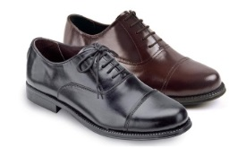
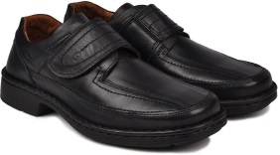
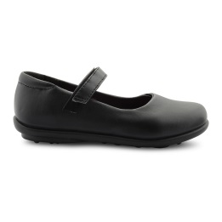

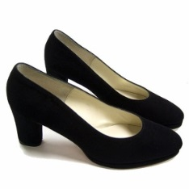
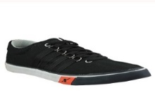
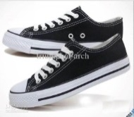
x
x
x

Please note : High heels, flimsy pumps, canvas shoes, trainer type shoes such as VANs, Converse or Adidas are not acceptable.

Weather Conditions

- In wet weather you are advised to bring an umbrella to school and leave it in your form room.
- In cold weather we recommend that you wear several layers (coat, jumper, shirt, white t-shirt) to keep warm. A school hoodie may be worn travelling to and from school but must be removed inside the school building. Coats can be left with your form teacher in the morning and collected in the afternoon.

The following sanctions will apply if you wear the incorrect uniform without a note from your parent / guardian:
On the first occasion:
- You will be given a warning that you must wear the appropriate school uniform.
- Where available, a replacement item of uniform may be offered to you on a temporary basis.
- You will be asked to remove prohibited items of jewellery.
On the second occasion:
- Your parent /guardian will be contacted by telephone and advised that you are wearing an incorrect item of uniform. If the item cannot be brought in to school, where necessary, you will be given grace to purchase the correct uniform by the following Monday.
- Where available, a replacement item of uniform may be offered to you on a temporary basis.
- Prohibited items of jewellery and can be collected at the end of the school day.

On the third occasion:
- Your parent will be asked to attend a meeting with the Principal / Vice Principal.
- You will remain with your form teacher until the meeting takes place.
- Prohibited items of jewellery will be confiscated and will have to be collected by your parent / guardian.
If you refuse to follow instructions there may be further sanctions applied.

WE REALLY APPRECIATE THE SUPPORT OF PARENTS / GUARDIANS IN MAKING SURE PUPILS FOLLOW OUR UNIFORM POLICY.

